Resisting a Carceral World: Abolitionism and Gender-Based Violence

Abstract
This working paper reflects on Resisting a Carceral World, a five-part workshop series (April–May 2025) organised through the Abolitionist Book Club to explore abolitionist responses to gender-based violence. The paper considers the limits of criminal justice approaches and introduces transformative justice as a community-based alternative. Drawing on participant discussions, the facilitators of the workshops present recurring questions and concerns about accountability, survivor safety, power dynamics, and the burden of care within communities. While acknowledging the tensions and uncertainties surrounding non-carceral responses, it argues that creating collective spaces for dialogue, critical reflection, and small-scale action is a necessary step toward building sustainable, transformative approaches to ending gender-based violence.
***

Workshop Overview

Abolitionist approaches to gender-based violence have emerged in response to the limitations of the criminal justice system in providing sustainable solutions to gendered violence. Gendered violence is rooted in, and at times exacerbated by systems of oppression; whereas prisons offer individualistic solutions to violence focused on the body of the person who has caused harm (Verges, 2022; Olufemi, 2020). Abolition feminism, then, is a collective effort to build strength in the grassroots, particularly vesting power in communities to offer solutions to gendered violence. The focus within this approach shifts from individual carceral responses to building alternative, transformative, and radical community-driven approaches which have been marginalised by racial capitalism (Davis et al, 2022; Gilmore 2022).
‘Resisting a Carceral World’ is a workshop series loosely designed and facilitated by us as part of the Abolitionist Book Club (ABC). Running from April to May 2025, the programme comprised five sessions that engaged with: (1) abolitionism and gender-based violence (an overview), (2) carceral feminism, (3) collective care and justice, (4) mapping community allyship, and (5) the development of creative, co-produced outputs. Consistent with ABC’s ethos, the series sought to cultivate dialogue, critical reflection, and knowledge exchange concerning non-carceral responses to gender-based violence, emphasising everyday practices of transformation, community-building, and resistance.
Although held on campus, the sessions were deliberately structured to minimise hierarchy: we welcomed participants to join a circle in the centre of the room to encourage openness and co-learning. Workshop activities included collective readings, small and large group discussions, and collaborative creative work. We also incorporated adapted role-play exercises to support the participation of group members with visual impairments. Attendance across the series ranged from seven to ten participants each week, including postgraduates, doctoral researchers, academic staff, professional services staff, and local community members, some of whom were affiliated with survivor-support organisations. We also observed that there were fewer participants of colour – a pattern that warrants further reflection on barriers to access and engagement.

Transformative Justice: Thoughts, Worries, Questions

For this section of the working paper, we want to set our focus on the thoughts, worries and questions which so often infiltrate discussions of abolitionism in the context of gender-based violence. In almost all debates about police and prison abolition, someone will undoubtedly ask: “What about the rapists?” (Davis et al, 2022). This inevitable question lies in very simplistic stories about gender-based violence, and particularly sexual violence: if you’re bad, you go to jail, if you’re good, the police will protect you. While this story appears to be conveniently tidy, it does not reflect the reality of Black, queer, trans, indigenous, poor, or non-binary communities who are more likely to be on the receiving end of state violence (Davis et al, 2022). Thus, it is no surprise that systemic policing failures in safeguarding women and gender minorities from violence are entrenched in high levels of distrust of the police (Gill and Anitha 2024).

Additionally, many of the people and places thought to protect the public from gender-based violence are often sources that inflict that very same violence. The deluge of scandals exposing rape and domestic violence perpetrated by police officers, as in the case of Sarah Everard, is but one example, as is the long-recorded issue of state-sanctioned sexual violence perpetrated by prison and detention centre guards (Day and McBean 2022). So, what of the police officer who is the rapist? Or, when cops bring violence, not relief, to your door? Contrary to your neighbour, partner or family member, this abuse carries the power and protection of the state, and consequently these simple stories fall apart (Davis et al, 2022). Through this lens, we cannot rely on better police training, or speedier court processes that discriminate against marginalised communities as viable long-term solutions to the issue of gender-based violence, particularly because these very processes and practices are engulfed in racist and sexist structures (Beddows 2022).

Against this backdrop, what we saw in our workshops is that the solutions to gender-based violence are less than straightforward; rather, they are murky and complicated. In our third session on collective care and justice, we explored different forms of justice. There was a collective recognition and understanding of legal systems/definitions of ‘justice’, but less so of alternative forms of justice that do not rely on the state. The purpose of this session was to invite a group reading of transformative justice – an abolitionist framework that understands systems such as police and prisons as inherently violent to maintain social control (Mingus, 2022). This is echoed in Abolishing the Police, in which Koshka Duff writes that the purpose of the police is not to fight oppression nor to reduce violence, but to uphold ‘public order’; that is, the order of capital and private property, of white supremacy, of patriarchy (Duff 2021: 7). Given these roots, improving an institution within which classed, racialised and gendered power dynamics are embedded, is an extremely limited intervention (O’Neill 2025). Seeing the oppressive violence that goes into upholding what passes for order (despite the disorder and trauma it spells for many) is not only central to the arguments against policing, but pivotal in seeing how things might be otherwise (Duff 2021). Thus, transformative justice works to build an alternative, acknowledging that to end incidences of violence, we must end the conditions that create and perpetuate them: capitalism, poverty, white supremacy, misogyny, ableism, and war, to name a few.

Discussions of transformative justice are also discussions that recognise our communities as imperfect. Often, the way in which communities respond to violence can be just as harmful as the state, including the shaming, blaming, isolating, attacking and threatening of those who have been harmed (Mingus, 2022). However, the overarching belief is that there is a greater possibility for transformation in our communities than in the state. Transformative justice recognises that addressing and reducing violence is not solely about what we do not want but practicing what we do want: healthy relationships; good communication skills; skills to de-escalate active or “live” harm in the moment; expressing ourselves in ways that are not destructive but healing for our communities. For instance, taking accountability for any harm that we are complicit in, and supporting community members’ skills to interrupt violence while it is happening.
While some participants were more welcoming of this approach, it felt less convincing for others and invited a flux of thoughts, worries and questions:

How can we trust each other?
How do we begin without everyone on board?
Who ends up doing the work?
Who/How do we hold communities accountable?
Who decides and facilitates justice?
What about the power dynamics in communities?
What might consequences look like from an
abolitionist and community allyship lens?
How do we ensure survivor safety?
Who shoulders the burden?

Echoing our earlier thoughts, these questions comprise less than straightforward answers, but are nonetheless questions we must continue to grapple with. Being in the company of many questions, even when we don’t have the answers, and sharing our worries is far more conducive than no questions at all. They help us to think better about collectively ending gender-based violence and other abolitionist goals.
The work that abolitionist approaches to violence requires us to do can feel ‘abstract’, and leave many of us wondering, ‘where and how do we start?’. In our final session, we planned a short debrief that evolved organically into a more expansive roundtable discussion. We shared and organised our reflections into four categories: things that stood out, challenges, questions, and actions. Here, we note some of the actions the group proposed to help translate complex ideas into small individual and collective ways of practicing this work:
1. Read more. What we covered was the tip of the iceberg.
2. Practice small ways of relying on each other.
3. Create spaces to educate, inform and learn.
4. More radical forgiveness (not dismissing harm but acknowledging wrongdoing while recognising the potential for transformation in the person that has caused harm).
5. Collect examples of what accountability and consequences can look like.

Collective care and Community-building

For those who are marginalised, care is a form of political warfare:
to engage in care is to uphold the right to survive
(Lorde, 1988).

In our session on community allyship, a participant brought bananas to share with everyone. During the co-production part of the session, as the participants were discussing collective care and community-building, they inadvertently channelled their relationship with care into art and doodles on the banana skin. These bananas were taken home and baked into a banana bread, which was brought in the next session to share among the attendees. Through these naturally occurring moments of creative co-production, collective care, and community-building, the bananas came to symbolise mutual aid by the participants. During the session, a pressing critique also emerged - participants who had lived experience of providing care for their loved ones expressed that collective care was a form of care work. They expressed anxieties around this, stating that the care work involved in community-building might replicate the disproportionate burden of care borne by women and people from marginalised gender identities.

Such a practice of care has been produced by and for racial capitalism and requires the responsibility of care to be individualistic, rather than community-based. Collective care, on the other hand, can be retooled to address persistent forms of exclusion and domination (Ticktin, 2024). The politics of structural care articulated by the Black Lives Matter movement disrupts the idea of care as built on hierarchy, volunteer-based, and individual responsibility. Rather, the revolutionary potential of care is foregrounded by highlighting the interconnectedness between care and political organising. In the case of abolitionism and community-building, Ticktin (2024) advocates for a long-term politics of care - one that transforms communities. Such an idea of care is underpinned by the notion of care being a collective endeavour, one that goes beyond caring only for one’s own family. Collective care is performed by everyone within communities for each other, breaking the individualistic notion of care performed by certain individual members of the community, for those falling on a higher level of hierarchy in the community. Collective care is underpinned by the goal of creating a society wherein everyone can care and be cared for; where everyone matters.

While exploring ideas that go beyond individualistic notions of care, the participants sought radical hope in the possibility of collective care. Disillusioned by living in an individualistic world, it created space for an alternative imagining. Disproportionate and individualistic notions of care had created a barrier to engaging with anti-carceral frameworks of justice. In parallel, this raised questions within the group about the role of community support in shaping viable alternative futures, revealing how concerns about collective care can inhibit the imagining of non-carceral responses to harm. However, this does not necessitate a return to carceral systems; rather, it offers a stepping stone towards more nuanced conversations about ending gender-based violence.

As we step back to reflect on the learnings from the workshop series, it becomes imperative to foreground radical hope. Radical hope here means that we collectively create something, even if in this initial instance, it is creating the space to engage in dialogue. In the second iteration, we hope to develop this into something better that enables us to start moving away from the ‘abstract’ to more tangible and achievable actions. It is a collective commitment to knowing that there is no straightforward solution and that there may not be immediate rewards to the work we do. However, we can be assured that these very small actions have the potential to contribute to the longer-term goal of ending violence within our communities and creating meaningful social change.

References

Beddows, A. (2022) ‘Towards a World without Gendered Violence’ Available at: https://www.transformingsociety.co.uk/2022/12/15/zara-aleena-towards-a-world-without-gendered-violence/ (Accessed: 17 November 2025).

Davis, A. Y., Dent, G., Meiners, E. R., Richie, B. E. and evans, n. t. (2022) ‘Why Policing and Prisons Can’t End Gendered Violence’ Available at: https://www.bostonreview.net/articles/why-policing-and-prisons-cant-end-gender-violence/ (Accessed: 17 November 2025).

Davis, A. Y., Dent, G., Meiners, E. R., Richie, B. E. (2022) ‘Abolition. Feminism. Now.’ United States, Haymarket Books.

Day, A. S. and McBean, S. O. (2022) ‘Abolition Revolution’ London, Pluto Press.

Duff, K. (2021) ‘Abolishing the Police’ Dog Section Press.

Gill, A. K. and Anitha, S. (2024) ‘A matter of trust: Improving policing responses to violence against women and girls in racially minoritised communities. University of Bristol.

Gilmore, R. W. (2022) ‘Change Everything: Racial Capitalism and the Case for Abolition’ Chicago, Haymarket Books.

Lorde, A. (1988) ‘A burst of Light: Essays New York’ Firebrand.

Mingus, M. (2019) ‘Transformative Justice: A Brief Description’ Available at: https://transformharm.org/tj_resource/transformative-justice-a-brief-description/ (Accessed: 17 November 2025).

Olufemi, L. (2020) ‘Feminism, Interrupted: Disrupting Power United Kingdom’ Pluto Press.

O’Neill, S. (2025) ‘Questions for Abolitionists’ Available at: https://npolicemonitor.co.uk/uncategorized/questions-for-abolitionists/ (Accessed 04 December 2025).

Ticktin, M. (2024) ‘Care as Political Revolution?’ Focaal-Journal of Global and Historical Anthropology, Volume, 98. pp. 64–70.

Verges, F. (2022) ‘A Feminist Theory of Violence: A Decolonial Perspective United Kingdom’ Pluto Press.

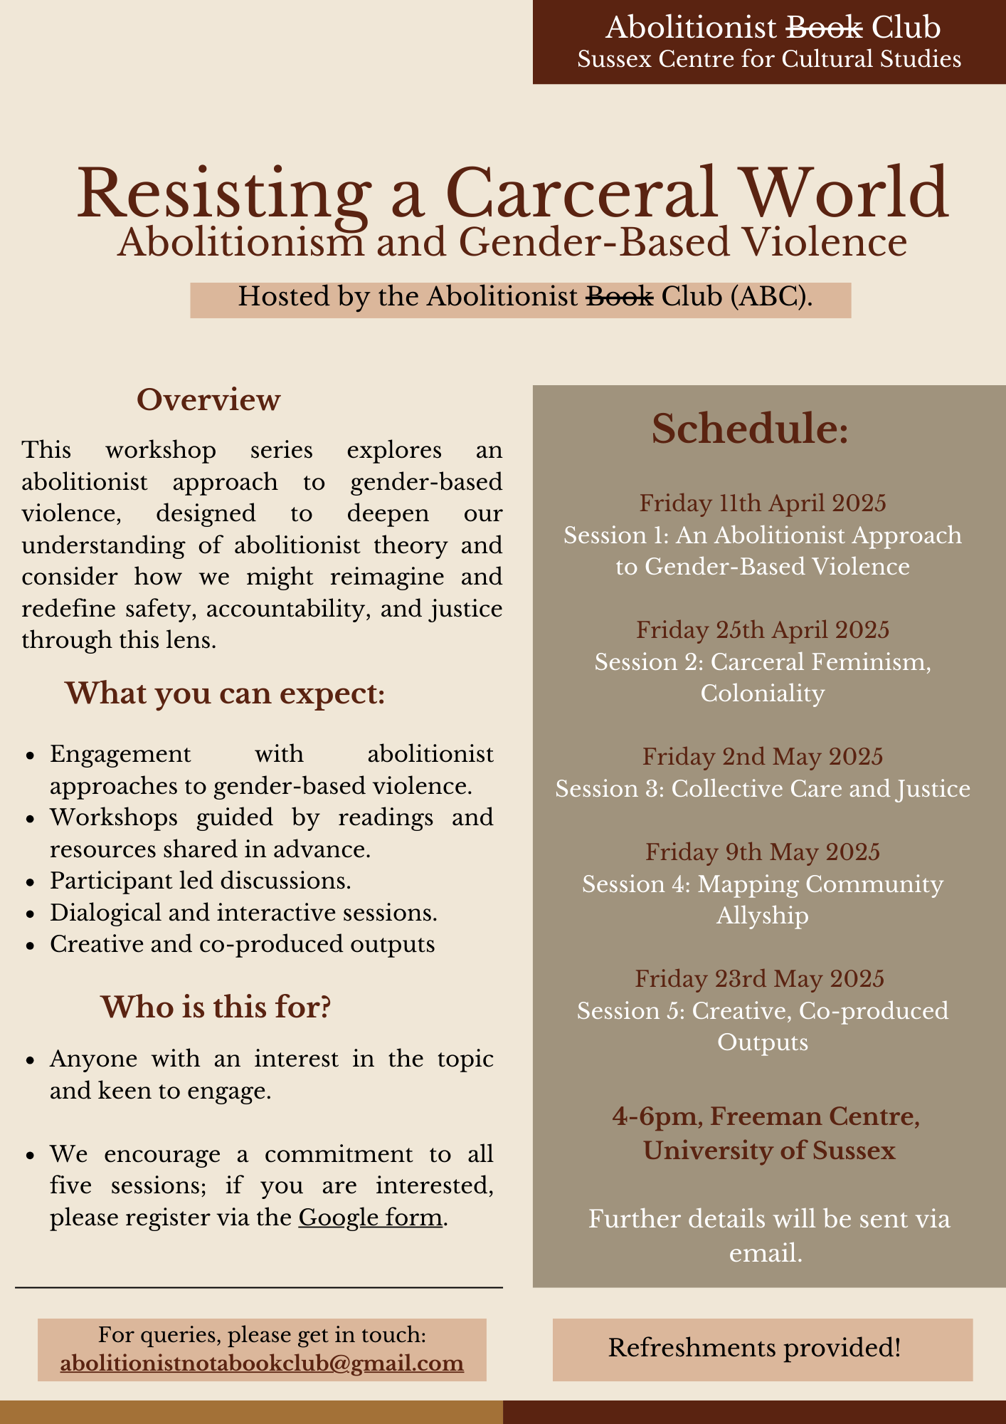
Image: Flyer for the ‘Resisting a Carceral World: Abolitionism and Gender-Based Violence’ workshop series at the University of Sussex.
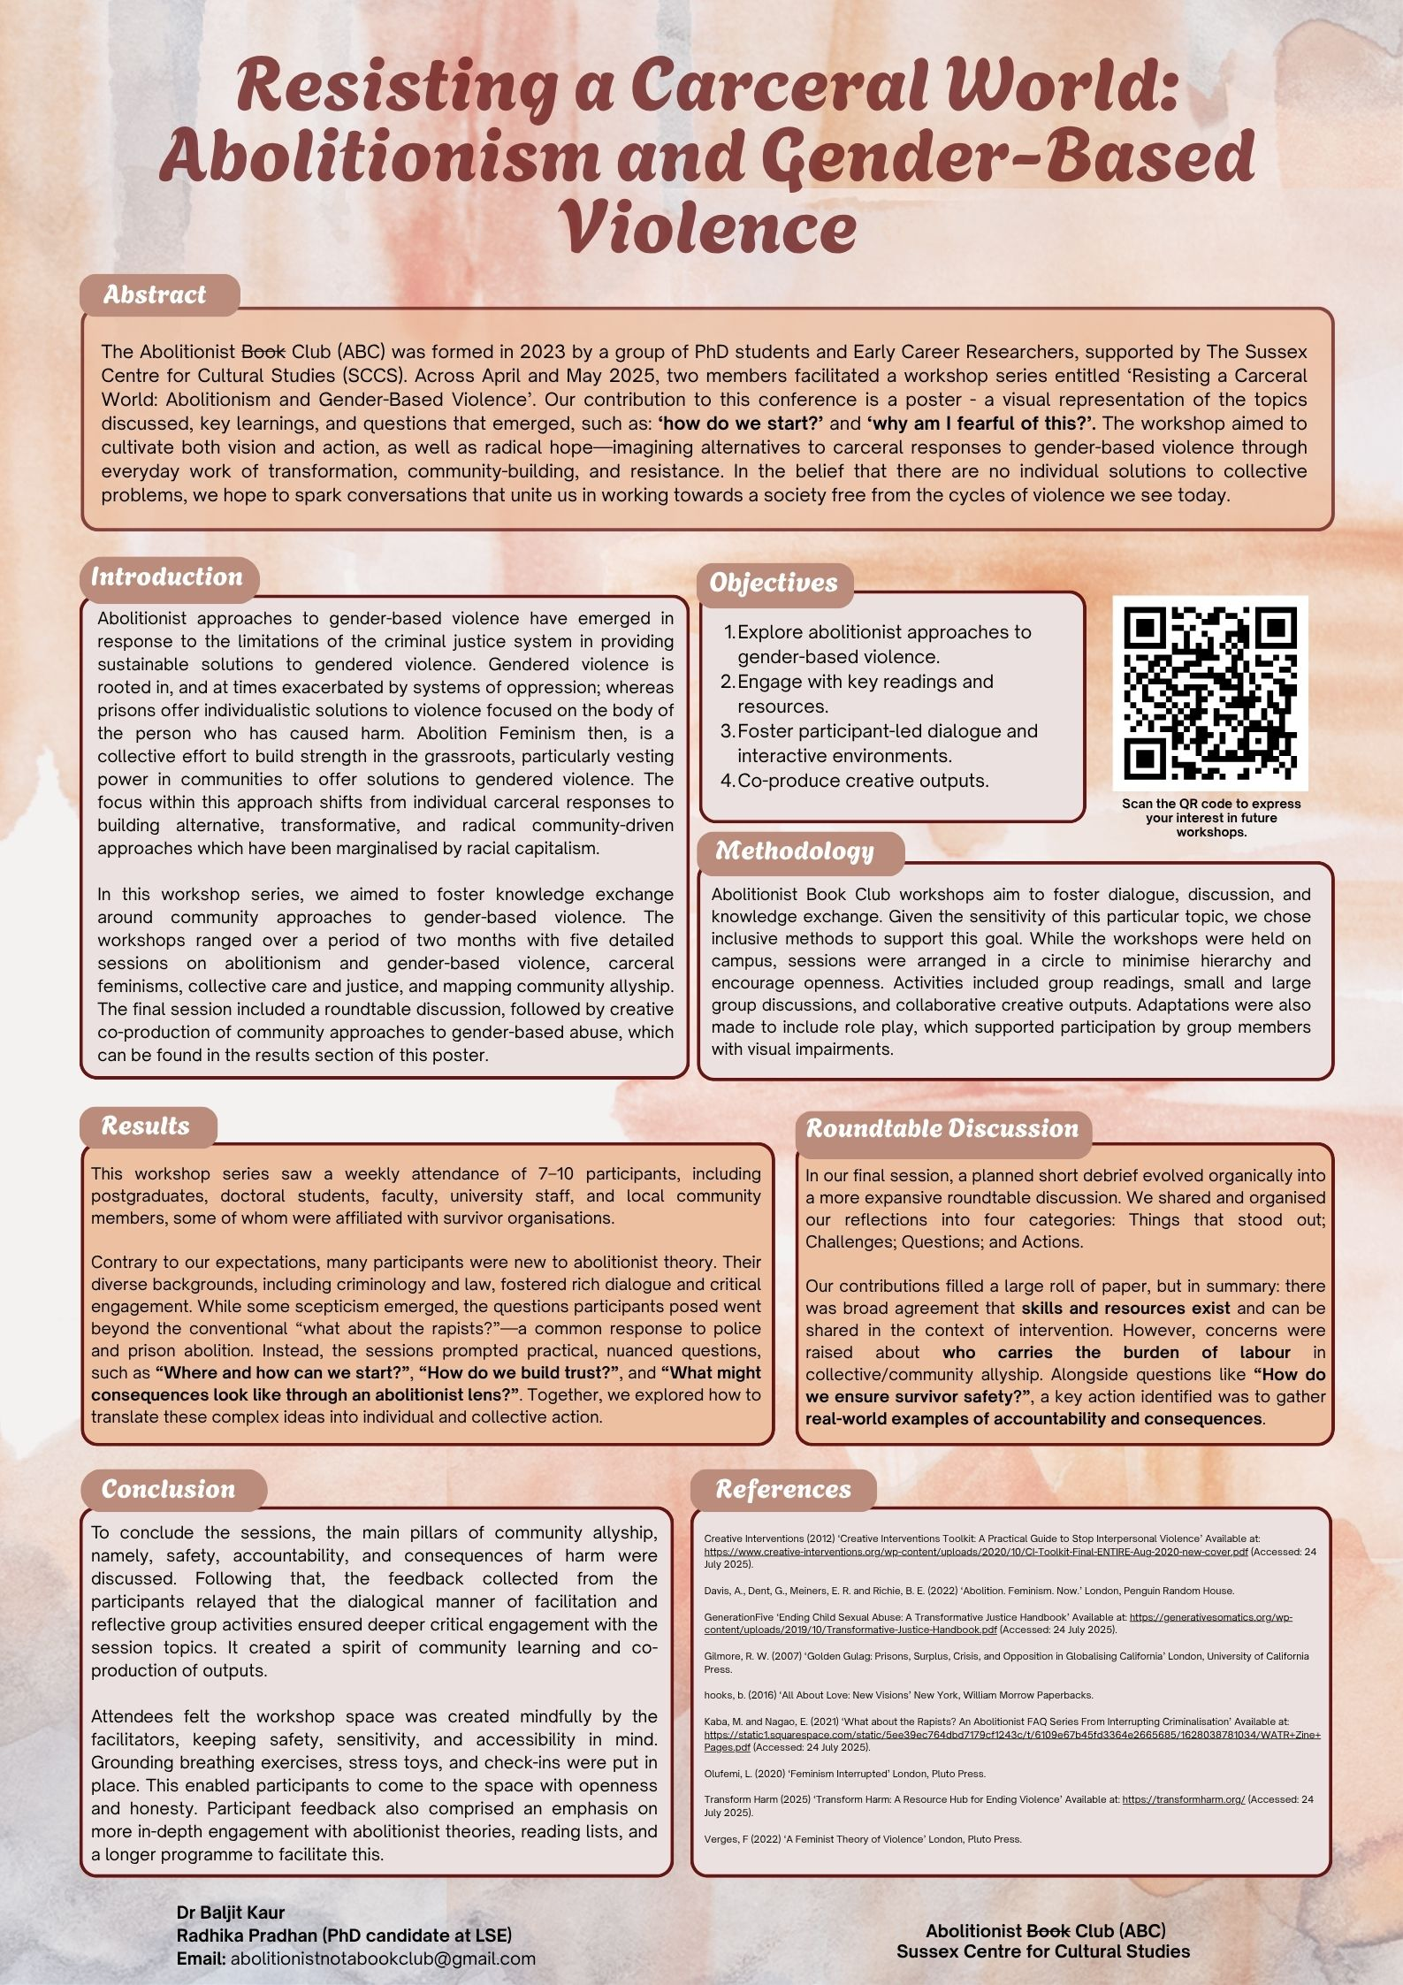
Image: Poster Presentation by Radhika Pradhan and Baljit Kaur for ‘A Feminist Politics of Radical Hope in a Time of Oppression’ conference at the University of Liverpool (2025).

Term used by several attendees to describe abolitionist praxis more broadly.

