Giornata contro 41 bis: Activism, Resistance, and the ARCI Network

Name: Dr. Nadia (Nedia) Buyse
Institution: Institute of Contemporary Music Performance, University of Sussex
Email: n.buyse@sussex.ac.uk

Name: Dr David Deacon
Institution: BIMM University London
Email: daviddeacon@bimm.ac.uk

Circola Arci which roughly translates into English as ‘cultural circle’, is a system of private social clubs and centres located throughout Italy. The concept of private leisure clubs is not exclusive to Circola Arci, there are many organisations with their own similar systems in Italy, such as ACLI - Associazioni Cristiane Lavoratori Italiani (or the Christian Association of Workers). Circola Arci positions itself in its history and present state as united through antifascist and socialist ideologies, some of those ideologies being pro refugee and immigrant, anti-mafia and anti-nationalism. The clubs themselves look and function in a variety of ways, but a portion of them act as music venues supporting underground musicians of varying genres. Due to the political nature of these club and their connections to international and marginalised communities, these spaces are often venues for international DIY and punk bands, particularly the more politically left aligning performers.

On January 24th, 2023, all the clubs within the Arci Network recognised a giornata contro 41 bis, ergastolo e tortura di Stato, or a day against 41bis, life imprisonment and state torture. This was in response to and acknowledged solidarity with an ongoing effort from anarchist Alfredo Cospito. 41bis or “supermax” is a prison system beginning in the 1970s which was meant to cut off prisoners particularly mafiosi(e), from the outside world. Alfredo Cospito was sentenced to 41bis in October 2022, in protest he began a hunger strike attempting to not only remove him from 41bis but also to abolish the system itself. It was during the penultimate weeks of this that Nadia was on tour with her solo music project DUBAIS and was observing the actions and ephemera that were central to the Circola Arci clubs and club members. This research acts as a survey and reflection of that ephemera and documentation of the actions undertaken by Arci and its members, particularly those involved in the underground music scene in Rome. It was during this research trip that Nadia (DUBAIS) performed at Fanfulla 5/a the Circola Arci venue that is the central case study for this research.

The research trips provided us the opportunity to interview varying people who have different levels of interactions with Arci clubs. We interviewed two organizers Cristina and Umberto from Mercolady, an ongoing weekly feminist queer party at Circola Caracol in Pisa. This interview illuminated the reasoning behind how these young anarchist students became involved as collaborators with the Arci network (which is notoriously managed by older socialists). As the Cirocla Arci clubs are privatised, this means clubs or spaces operating in this network don’t need to follow the same laws and regulations or even the same working practices as a non-privatized club or discotheque. They are not traditionally commercialised; they don’t have to make events and programming that appeals to everyone and anyone, but rather focused events for specific communities. Instead of paying for ticket fees or entry prices, an Arci member will pay around 8.00€ for a yearly membership and then will pay an entry fee usually between 3-10€ for events, concerts or programmed evenings. Because there is less reliance on programming events that will be commercially viable, and more attention paid to having the club open to and for members every night, Arci clubs are more open to whom they partner with as programmers and event curators. They are also open to whom they invite to perform in the spaces; they are looking to provide entertainment for people reflective of their own ethos and communities. Because of this, it’s more likely that an act is booked because of their aesthetics and political leanings rather than their Spotify stream numbers.


Image taken by Nadia Buyse. January 8^{th,} 2024.

We interviewed Bernardo Santerelli and Manuela (Maru) Marugj, two former Arci organizers from Rome who are also touring artists that were performing at Arci clubs around Italy during the time of this study. Barnardo and Maru are musical collaborators who both live predominately in Berlin but grew up identifying as queer feminist punks in the city of Rome. Between 2000-2008 they formed a band called Dada Swing and they are currently in the band Nebel3000 with Brezel Göring, formerly of the band Stereo Total. In the early 2000s both Maru and Bernardo, alongside other musicians and programmers in Rome, were active in booking, promoting and supporting bands almost exclusively within the Arci Networks or squatted spaces such as Forte Prenestino. It was through these sorts of networks and connections that seminal feminist punk bands such as Team Dresch and Bikini Kill were able to come and play in Italy. In 2000 Bernardo programmed and tour managed the band the Frumpies in a tour happening mostly in squats and Arci venues. It is through this connection to Olympia underground music that Nadia, Maru and Bernardo initially met in the early 2000s. We spoke with the Arci directors from various clubs in Rome about the Cospito case and why the network positioned themselves in solidarity with this action and how it aligns to their own ethos and ideologies. This group discussion/ interview took place as the ARCI leaders were meeting near the Cavour underground station enroute to a demonstration supporting Palestine in front of the Foro Romano (Roman Forum) this January. Along with this discussion we did an in-depth interview with Emmanuel (Manu) Bonetti about being a director of Fanfulla 5/a the Arci club where Nadia was invited to perform. We talked to Manu about how Fanfulla differs from not just mainstream clubs in Italy, but also other clubs within the Arci Network itself. From these interviews we came to understand that CIrcola Arci, while quite assertive in its intentions and political standings as an organization, is also welcoming for all to join and to even facilitate a club within their organization. Arci clubs exist all over Italy, within Rome alone there are multiple clubs.

Through this field research of group discussions/ interviews in action (whether before a show, or before a demo) we generated ethnographic and qualitative insights into the operation of the ARCI network, including Nadia’s auto-ethnographic perspective as a touring artist within these clubs and how she has found a fanbase/ community within this space. This paper will present the case for ARCI’s ongoing and reinvigorated social and cultural importance across Italy in the 2020s, connecting its political roots in the 1968 generation to current commitments binding music, culture, and politics together and exploring tensions between them. It is to be presented this year at KISMIF Conference in Porto, PRT and published in their coinciding peer review publication entitled DIY, Alternative Cultures, & Society through Sage Journals.

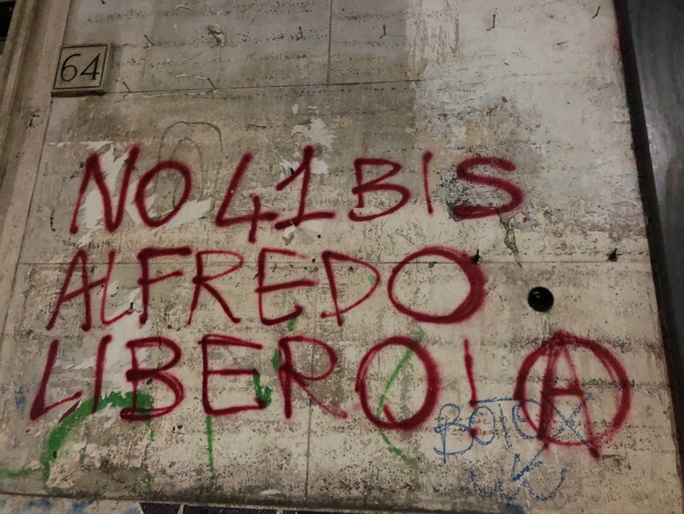
Image taken by Nadia Buyse, near Fanfulla 5/a, April 2023, artist unknown

